PAPER TITLE (Times New Roman 14)
First Author¹, Second Author² (Times New Roman, Bold, Font Size -12)
¹Designation, Department, Institute, City, State, Country (Font Size -10)
²Designation, Department, Institute, City, State, Country
ABSTRACT - Times New Roman, 12 pt, Bold
- Heading: Abstract text: Times New Roman, 10 pt
- Alignment: Justified
- Paragraph: Single paragraph
- Maximum: 200 words
- Indentation: First line indentation may be used.
- The abstract should not contain unnecessary references, tables, figures, or detailed explanations.
Abstract text:
The abstract should provide a concise and informative summary of the complete research work. It should briefly describe the background or research problem, objective of the study, methodology or research approach, major findings, and principal conclusion. The abstract should enable readers to understand the purpose and significance of the research without referring to the complete manuscript. Authors should avoid unsupported claims, unnecessary citations, abbreviations, tables, and figures in the abstract. The abstract should normally be written as a single paragraph and should not exceed 200 words.

Keywords
- Label: Times New Roman, 10 pt, Bold
- Keywords: Times New Roman, 10 pt
- Number: 5–6 keywords
- Separate keywords using commas.
Example:
Keywords: Research, Analysis, Methodology, Investigation, Data Analysis, Findings

1. INTRODUCTION
- Heading: Times New Roman, 12 pt, Bold
- Text: Times New Roman, 10 pt
- Alignment: Justified
- Paragraph: First-line indentation
The introduction should provide the background and context of the research topic. It should explain the importance of the subject, identify the research problem or knowledge gap, summarize relevant previous research, and clearly state the objectives or research questions of the study. The section should establish the rationale for conducting the research and provide a logical foundation for the methodology and analysis.

2. METHODOLOGY
- Main heading: Times New Roman, 12 pt, Bold
- Main text: Times New Roman, 10 pt
- Alignment: Justified
This section should describe the methods and procedures used to conduct the research. It should provide sufficient information regarding the research design, study population or sample, data sources, materials, instruments, variables, data collection procedures, and analytical techniques, as applicable to the study.

2.1 Research Design
- Subheading: Times New Roman, 10 pt, Bold
- Text: Times New Roman, 10 pt
- Alignment: Justified
Describe whether the research is quantitative, qualitative, experimental, observational, descriptive, analytical, computational, or based on a mixed-method approach.

2.2 Data Collection
Explain the source and method of data collection, sample selection, instruments, datasets, experimental conditions, or other relevant procedures.
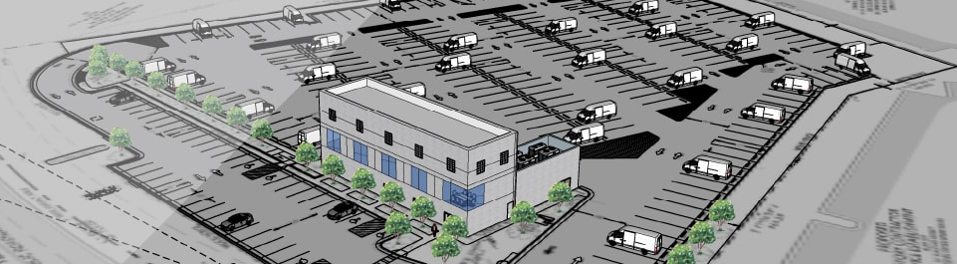
Figure 1: Building Plan (times new roman – 10 pt)

2.3 Data Analysis
Describe the statistical methods, mathematical models, algorithms, software, qualitative techniques, or other analytical procedures used to analyze the collected data.

3. RESEARCH FRAMEWORK AND ANALYSIS
- Heading: Times New Roman, 12 pt, Bold
- Text: Times New Roman, 10 pt
- Alignment: Justified
Present the theoretical framework, analytical model, experimental procedure, computational process, or conceptual framework used in the study.
Relevant variables, assumptions, equations, models, algorithms, parameters, and evaluation criteria should be explained clearly.
Figures and equations should be numbered consecutively and referred to in the manuscript.
Figure 1: [Descriptive title of the figure]
Font: Times New Roman, 10 pt

4. RESULTS AND DISCUSSION
- Heading: Times New Roman, 12 pt, Bold
- Text: Times New Roman, 10 pt
- Alignment: Justified
- Tables: Times New Roman, 10 pt
Present the findings in a logical sequence. Tables, graphs, charts, and figures may be used wherever they improve the presentation of the results.
The discussion should interpret the findings rather than simply repeat the numerical results. Where appropriate, findings should be compared with previous research and possible explanations for similarities, differences, or unexpected observations should be discussed.

Table Formatting
Table 1. [Descriptive Table Title]
S.N. | Parameter | Result | Interpretation
1 | [Parameter A] | [Value] | [Finding]
2 | [Parameter B] | [Value] | [Finding]
3 | [Parameter C] | [Value] | [Finding]
- Table text: Times New Roman, 10 pt
- Table title: Times New Roman, 10 pt, Bold
- Tables should be numbered consecutively.
- Every table should be referred to in the manuscript.
- Avoid unnecessary decorative colors or excessive borders.

5. CONCLUSION
- Heading: Times New Roman, 12 pt, Bold
- Text: Times New Roman, 10 pt
The conclusion should summarize the principal findings and clearly address the objectives or research questions of the study. It may include the significance, practical implications, limitations, and possible directions for future research.
The conclusion should be different from the abstract and should not introduce new findings that have not been discussed in the manuscript.
Graphs and tables should normally not be included in the Conclusion section.

ACKNOWLEDGEMENTS
- Heading: Times New Roman, 12 pt, Bold
- Text: Times New Roman, 10 pt
- Optional section
Authors may acknowledge individuals, institutions, funding agencies, laboratories, technical staff, or other contributors who provided meaningful assistance or support for the research.

6. REFERENCES
- Heading: Times New Roman, 12 pt, Bold
- Reference text: Times New Roman, 10 pt
- Numbering: Square brackets [1], [2], [3]
- References should be arranged in the order in which they are cited in the manuscript.
Examples:
[1] Author, A. A., “Title of the Research Article,” Journal Name, Vol. XX, Issue X, pp. XX–XX, Year.
[2] Author, B. B. and Author, C. C., “Title of the Study,” Journal Name, Vol. XX, No. X, pp. XX–XX, Year.
[3] Author, D. D., Title of Book, Publisher, City, Year.
[4] Author, E. E. et al., “Title of Research Work,” Journal Name, Vol. XX, Issue X, pp. XX–XX, Year. DOI: XXXXX.

